**Week 6 Assignment**

Shlok Manandhar

Westcliff University

PRG 402: Mobile Programming Applications

Prof. Khanal

April 13, 2025

**Firebase**

Firebase is a backend-as-a-service (BaaS) platform developed by Google in order to assist developers in developing, managing, and deploying applications, on mobile or on the web. All products from HERоку provide an easy path to apps with a suite of tools for authentication, hosting, analytics, cloud functions and databases. Firebase Realtime Database is one of the components of Firebase that provides a cloud hosted NoSQL database. It stores the data as JSON and synchronizes the data in real time real time between all connected clients. In other words, changes made with the data are reflected on all devices or applications subscribing to that data, instantly, that is why it is great for applications that need to get live updates, like chat applications, collaborative tools and real time analytics.

**Code of the project**

The html file.

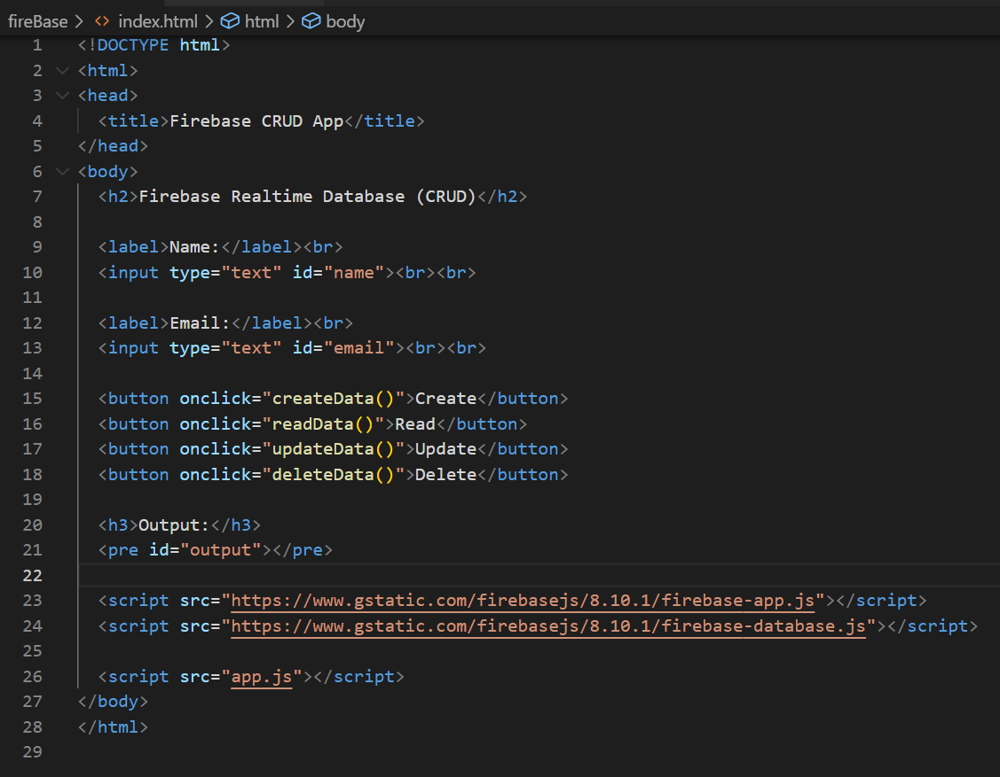

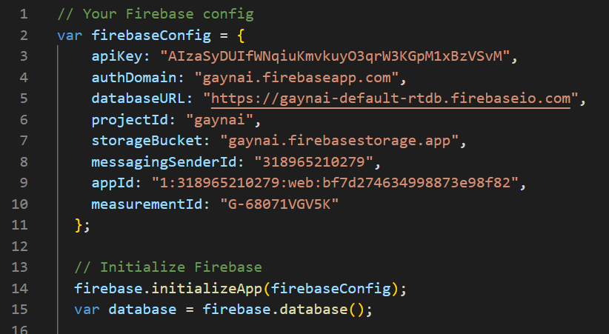

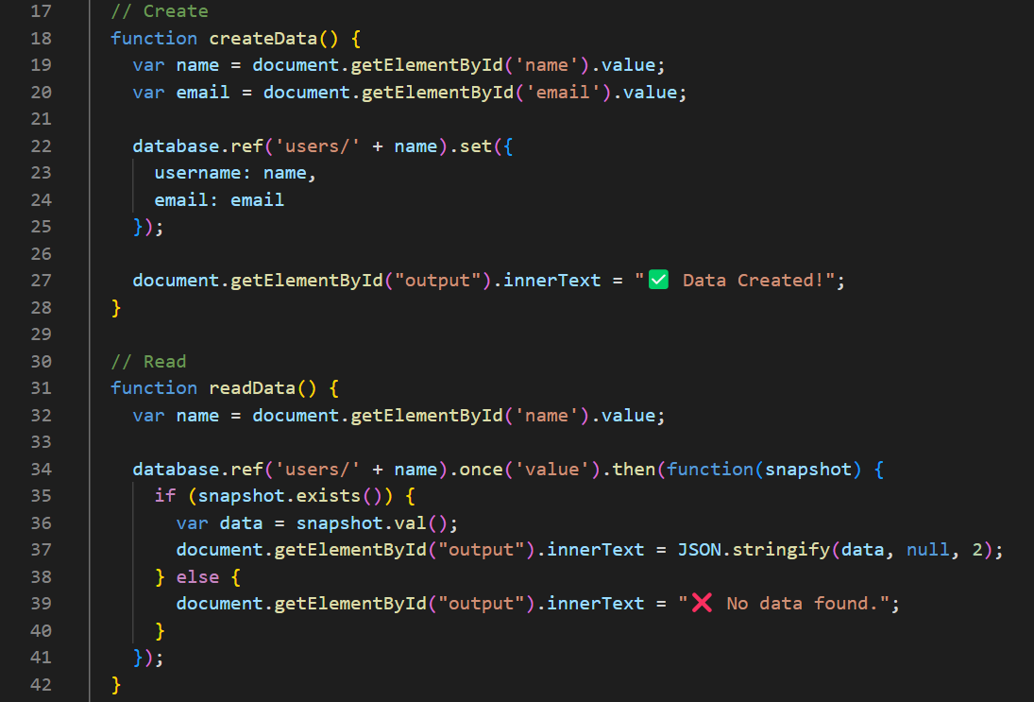

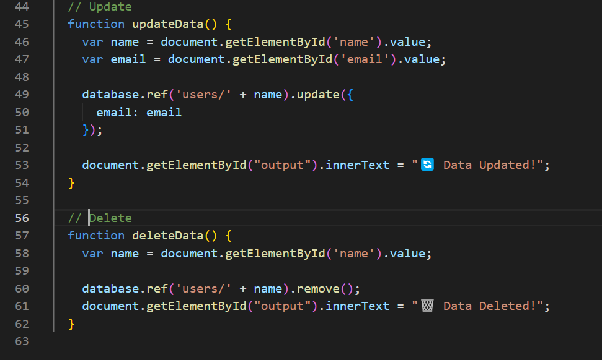

This web application functions as a basic interface with Firebase Realtime Database to conduct Create, Read, Update and Delete actions.

* Users can enter their name and email through HTML fields before executing CRUD operations with the provided buttons.
* The initialization of Firebase occurs through a specific configuration which enables database connection for the Realtime Database.

Functions used

* createData(): Adds the user's data (name and email) to Firebase.
* readData(): Retrieves and displays the user's data based on the name.
* updateData(): Updates the user's email in Firebase.
* deleteData(): Deletes the user's data from Firebase.

**Demo of the project**

1. First when the project was created.

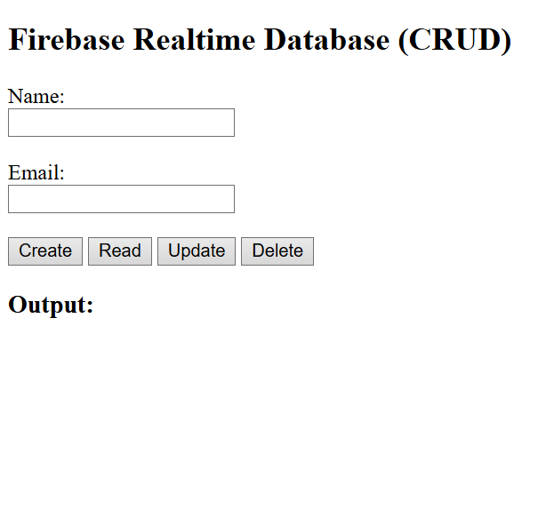

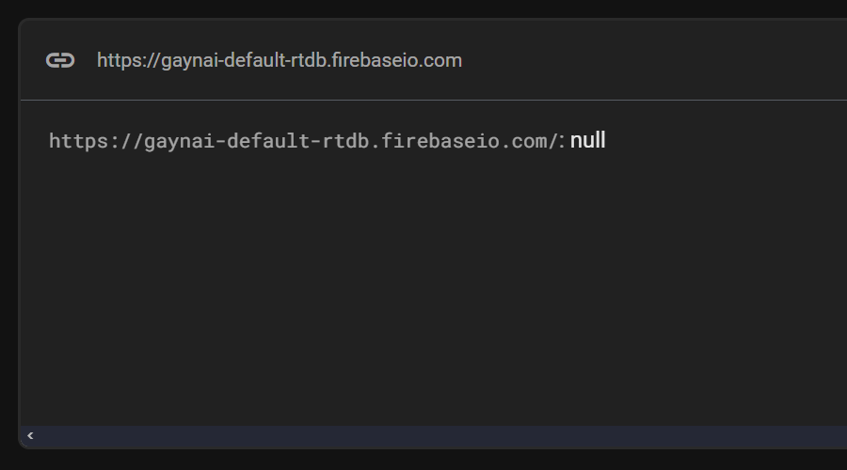

1. When data was given.

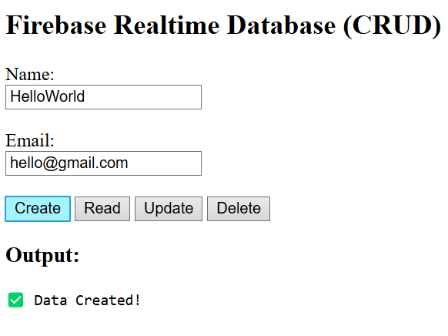\

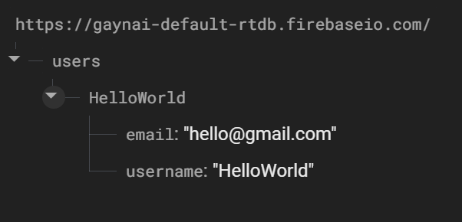

1. Used to find data, by giving name only.

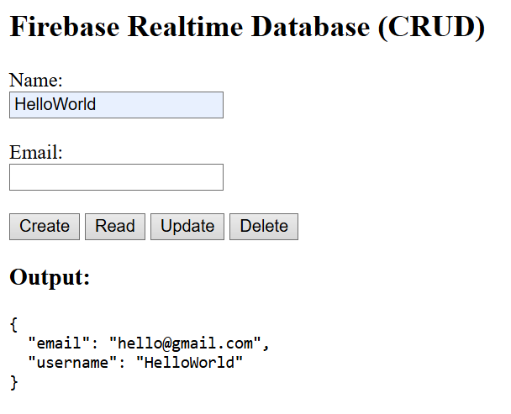

1. Update data.

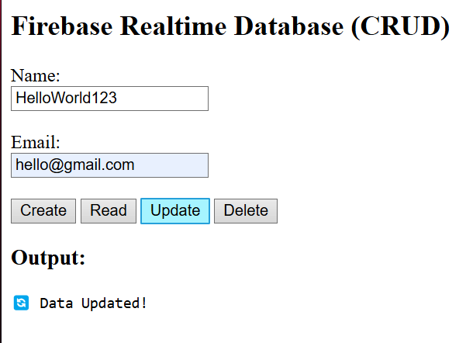

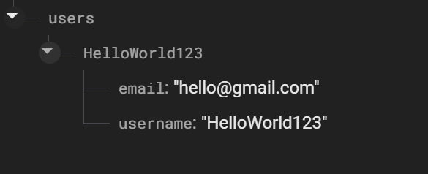

1. Deleting data.

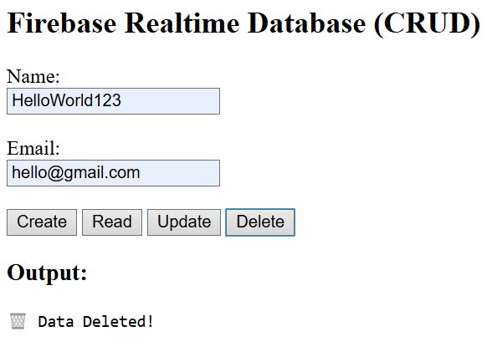

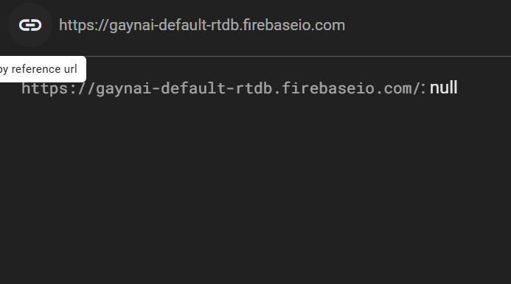

1. When data is not found

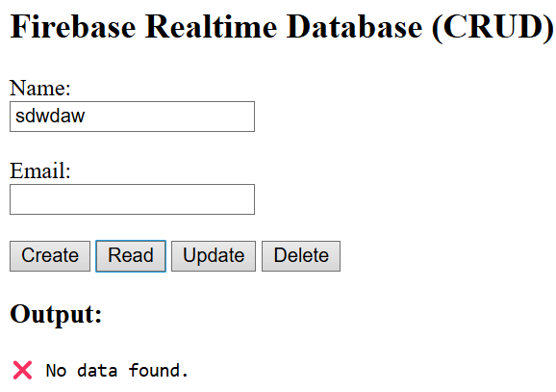

References

*Firebase Realtime Database | Store and sync data in real time*. (n.d.). Firebase. <https://firebase.google.com/products/realtime-database>

*Firebase Realtime database*. (n.d.). Firebase. <https://firebase.google.com/docs/database>

Github link <https://github.com/ShlokManandhar5/Mobile_App.git>